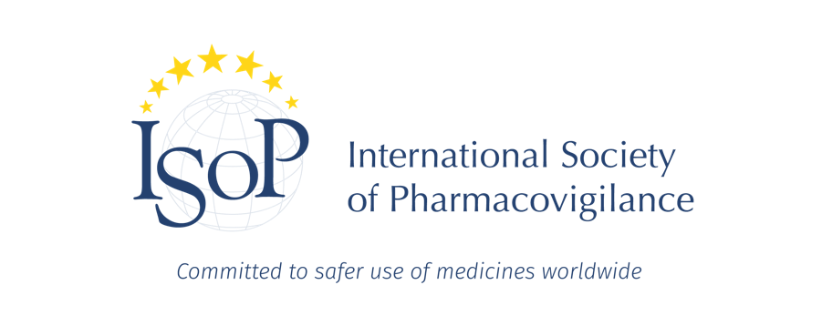
ISoP Mid-Year Symposium 2023
1-2 June 2023, Leiden, Netherlands (Rijksmuseum Boerhaave)
Pharmacovigilance: where science meets clinical practice

Programme

Day 1- Thursday, June 1
Synergy between pharmacovigilance, clinical pharmacology and epidemiology to improve patient safety
Session UTC+1 | Session title |  |  | Speaker to invite
08.30-09.00 |  | Registration
Session 1  09.00-10.30 |  | How can Pharmacovigilance, Epidemiology and Clinical Pharmacology collaborate to decrease harm of medicines?
09.00-09.10 |  | Welcome and Introduction
25’ |  | Synergy between PV-CP-EPI from a clinical pharmacological perspective
25’ |  | The synergy between PV-CP-EPI from an epidemiological perspective
25’ |  | The synergy between PV-CP-EPI from a Pharmacovigilance perspective
15’ |  | Panel discussion
10.30-11.00 |  | Coffee Break and networking
Session 2  11.00-12.30 |  | Do we need to re-think the concept of causality?
30’ |  | Causality on group and individual level, how does it relates?
30’ |  | Dispositions and Causality Assessment in Pharmacovigilance
30’ |  | Panel discussion
12.30-13.30 |  | Lunch
Session 3  13.30-15.00 |  | Using information from other sources in PV
30’ or 25’ |  | The use of real world evidence in pharmacovigilance, the DARWIN project
30’ or 25’ |  | Hospital data warehouses for case retrieval in PV
30’ or 25’
2x7 mins |  | Abstract presentations
15.00-15.30 | Coffee Break and networking
Session 4  15.30-17.00 |  | Innovative methods in PV
30’ or 25’ |  | Knowledge integration for case assessment and prioritisation
30’ or 25’ |  | Dealing with DPA in the post-Covid era
30’ or 25’ |  | Neural network, what is het and what are the possibilities in PV?
2 x 7 mins |  | Abstract presentations
17.00-18.00 |  | EU Chapter session
End of Day 1

Day 2- Friday, June 2
Beyond spontaneous reporting: integrating data from multiple sources to ensure medicines safety
 | Welcome back and housekeeping
Session 5  09.00-10.30 | Implementing pharmacovigilance in clinical practice
30’ | TTS from signal to useful clinical guidelines
30’ | The role of pharmacogenetics in daily practice
30’ | Using apps for communication between patient and HCP to monitor and manage ADRs
10.30-11.00 | Coffee Break and networking
Session 6  11.00-12.30 | The role of patients in PV
25’ | Patients involvement in the safe use of drugs, CIOMS XI
25’ | Role of patients in the safety regulations, a perspective from the Patient and Consumer Working Party
25’ | Engaging Patients via Online Healthcare Fora: Three Pharmacovigilance Use Cases
2 x 7’ | Abstract presentations
12.30-13.15 | Lunch
Session 7  13.15-14.45 | What do stakeholders need from PV?
25’ | What do the general public need with regards to pharmacovigilance?
25’ | What to medical doctors need with regards to pharmacovigilance?
25’ | What do patients need with regards to pharmacovigilance?
15’ | Panel discussion
14.45-15.15 | Coffee Break and networking
Session 8  15.15-16.45 | Science and practice, joining forces in PV
25’ | Science and practice, joining forces to moving PV forward, reflections from an epidemiological perspective
25’ | Science and practice, joining forces to moving PV forward, reflections from a clinical perspective
25’ | Science and practice, joining forces to moving PV forward, reflections from a pharmacovigilance perspective
15’ | Panel discussion
 | Closing remarks
End of the Symposium

